**EXCEL PROJECT REPORT**

PROJECT: **To-Do List**

*Submitted by*

Bathily Ibrahim(22BCA11058)

*in partial fulfilment for the award of the degree of*

BACHELOR OF COMPUTER APPLICATIONS



Chandigarh University

April 2025

Table of Contents

ACKNOWLEDGEMENT 3

INTRODUCTION 4

1. Project Overview 5

2. Step-by-Step Implementation 5

3. Screenshots 6

4. Possible Extensions 7

5. Conclusion 7



# ACKNOWLEDGEMENT

I would like to express my sincere gratitude to all those who contributed to the successful completion of this Excel To-Do List Project.

First and foremost, I am deeply thankful to Ms. Muskan for their guidance, valuable feedback, and encouragement throughout the project. Their expertise helped me understand Excel’s powerful features, from conditional formatting to data validation making this project both educational and practical.

Lastly, I appreciate the patience and motivation from my friends who encouraged me to explore Excel’s potential beyond basic spreadsheets.

This project has been a great learning experience, and I look forward to applying these skills in future tasks.

# 

# INTRODUCTION

This project creates a simple to-do list in Excel that automatically:

✓ Tracks completed tasks with checkboxes & strikethroughs

✓ Color-codes by priority (High/Medium/Low)

✓ Uses dropdowns for easy input

Built with Excel's Conditional Formatting and Data Validation, it's a perfect blend of simplicity and functionality for personal or professional use.



# 1. Project Overview

Objective: Create an interactive to-do list in Excel with:

✔️ Checkbox completion tracking

✔️ Priority-based color coding (High/Medium/Low)

✔️ Optional dropdown menus for ease of use

Key Features

- User-Friendly: **Minimal manual input required.**

**-** Visual Feedback**: Colors and strikethroughs show progress at a glance.**

- Scalable**: Easy to add more tasks or columns (e.g., due dates).**



# 2. Step-by-Step Implementation

Step 1: Task List Setup

**- Column A (Tasks): List tasks**

**- Headers: Label Columns A, B, and C as Tasks, Status, and Priority.**

Step 2: Add Checkboxes

**1. Go to Developer Tab → Insert → Checkbox (Form Control).**

**2. Place checkboxes next to each task.**

Step 3: Priority Color Coding

**1. Manual Input (Option 1):**

**- Type "High," "Medium," or "Low" in Column C.**

**- Conditional Formatting Rules:**

**- `=$C2="High"` → Red fill.**

**- `=$C2="Medium"` → Yellow fill.**

**- `=$C2="Low"` → Green fill.**

**2. Dropdown Menu (Option 2):**

**- Select Column C → Data Validation → List → Enter `High, Medium, Low`.**

# 3. Screenshots

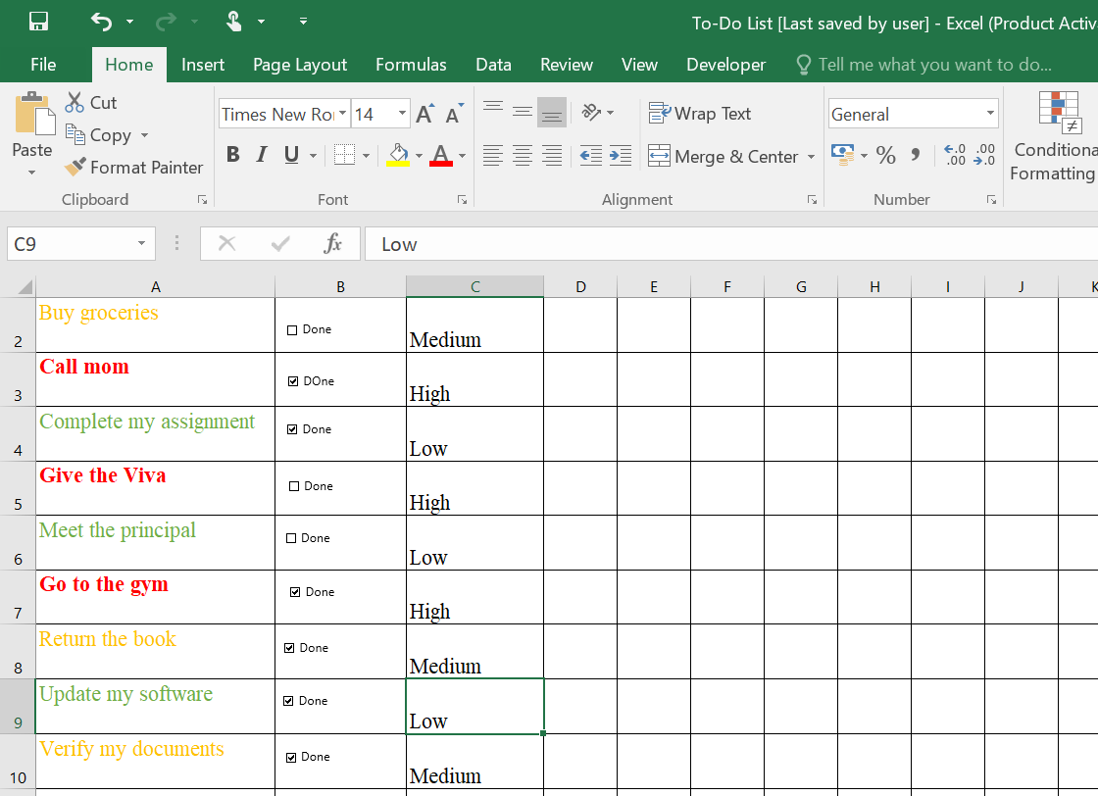

# 4. Possible Extensions

- Due Dates: Add a column and highlight overdue tasks in red.

- Progress Bar: Use a formula to show % of tasks completed.

- Macros: Automate sorting

# 5. Conclusion

This project demonstrates Excel’s capability for simple automation and visual task management. With minimal effort, users can track priorities and completion status efficiently.